University Of Wah (UOW)
Department of Computer Science

Course [Title/Code]:
Data Structures [CS-201L]
Submitted To:
Mrs. Muniba Khan
Submitted By:
Saaddi Safdar [UW-24-CS-BS-088]
Jawad Hussain [UW-24-CS-BS-108]
Lab No:
Open Ended
Date of Submission: 12th January 2026

Task# ‘A’:
Part 1:
I) How Priority Queues differ from normal queues?
The Core difference (idea):
“In a queue, the first-in-first-out rule is implemented whereas, in a priority queue, the values are removed on the basis of priority. The element with the highest priority is removed first.”
Normal Queue: A linear data structure that follows the FIFO (First In First Out) principle. In this structure, the element inserted first is removed first, similar to people standing in a line at a bank counter.
Priority Queue: A special type of queue where each element is associated with a priority. Unlike a standard queue, elements with higher priority are dequeued before elements with lower priority.
Reference: 1) https://www.scribd.com/document/469685836/CO4-Priority-Queue
II) Why tree-based implementations (heaps, BSTs) are preferred over arrays in large-
scale systems?
Tree structures stay fast when data is huge, but arrays slow down when you change them a lot.​
- Trees (like BSTs, heaps) can add, delete, and find items in about $\log{n}$ time, which is good for large data.​
- Arrays may need to move many items when inserting or deleting, which is slow in big systems.​
Reference: https://stackoverflow.com/questions/37634731/data-structures-if-heaps-are-trees-why-are-they-implemented-internally-with-li
Part 2: Compare array-based priority queues and heap-based priority queues in terms of time
Complexity?
Unsorted array implementation
- Insert: O(1) (just put at the end).​
- Find/remove highest priority: O(n) (must scan whole array).​
Sorted array implementation
- Insert: O(n) (find place, then shift elements).​
- Find/remove highest priority: O(1) (at one end of array).​
Binary heap implementation
- Insert: O(log n) (bubble up in the heap).​
- Remove highest priority: O(log n) (swap, then heapify down).​
- Get highest priority (peek): O(1).​
Reference: https://www.geeksforgeeks.org/dsa/priority-queue-set-1-introduction/

Task ‘B’
Implementations [Code]:
#include <iostream>
using namespace std;

struct BSTNode {
int eventID;
BSTNode *left, *right;
};

struct PQNode {
int id;
int priority;
PQNode* next;
};

BSTNode* createBSTNode(int id) {
BSTNode* newNode = new BSTNode();
newNode->eventID = id;
newNode->left = newNode->right = NULL;
return newNode;
}

BSTNode* insertBST(BSTNode* root, int id) {
if (root == NULL) return createBSTNode(id);
if (id < root->eventID)
root->left = insertBST(root->left, id);
else
root->right = insertBST(root->right, id);
return root;
}

class TrafficManager {
PQNode* front;
BSTNode* root;

public:
TrafficManager() {
front = NULL;
root = NULL;
}

void enqueue(int id, int p) {
PQNode* newNode = new PQNode;
newNode->id = id;
newNode->priority = p;

if (front == NULL || p < front->priority) {
newNode->next = front;
front = newNode;
} else {
PQNode* q = front;
while (q->next != NULL && q->next->priority <= p) {
q = q->next;
}
newNode->next = q->next;
q->next = newNode;
}
}

void processEvents() {
while (front != NULL) {
PQNode* temp = front;
cout << "Processing Event ID: " << temp->id << " (Priority: " << temp->priority << ")\n";
root = insertBST(root, temp->id);
front = front->next;
delete temp;
}
}

void findMin() {
if (root == NULL) return;
BSTNode* curr = root;
while (curr->left != NULL) curr = curr->left;
cout << "Minimum Event ID: " << curr->eventID << endl;
}

void findMax() {
if (root == NULL) return;
BSTNode* curr = root;
while (curr->right != NULL) curr = curr->right;
cout << "Maximum Event ID: " << curr->eventID << endl;
}
};

int main() {
TrafficManager system;

system.enqueue(101, 1);
system.enqueue(505, 1);
system.enqueue(210, 2);
system.enqueue(155, 2);
system.enqueue(340, 3);
system.enqueue(480, 4);
system.enqueue(275, 4);
system.enqueue(99, 5);

system.processEvents();
system.findMin();
system.findMax();

return 0;
}
Output:
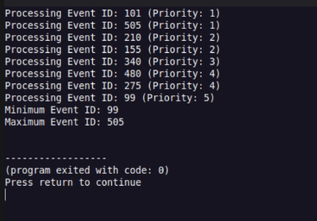

Task ‘C’
Implementation [Code]:
#include <iostream>
using namespace std;

struct BSTNode {
int eventID;
BSTNode *left, *right;
};

struct Event {
int id;
int priority;
};

class TrafficSystem {
Event pq[50];
int size;
BSTNode* root;

public:
TrafficSystem() {
size = 0;
root = NULL;
}

BSTNode* createBSTNode(int id) {
BSTNode* newNode = new BSTNode();
newNode->eventID = id;
newNode->left = newNode->right = NULL;
return newNode;
}

BSTNode* insertBST(BSTNode* node, int id) {
if (node == NULL) return createBSTNode(id);
if (id < node->eventID)
node->left = insertBST(node->left, id);
else
node->right = insertBST(node->right, id);
return node;
}

void enqueue(int id, int p) {
int i = size - 1;
while (i >= 0 && pq[i].priority > p) {
pq[i + 1] = pq[i];
i--;
}
pq[i + 1].id = id;
pq[i + 1].priority = p;
size++;
}
Output:
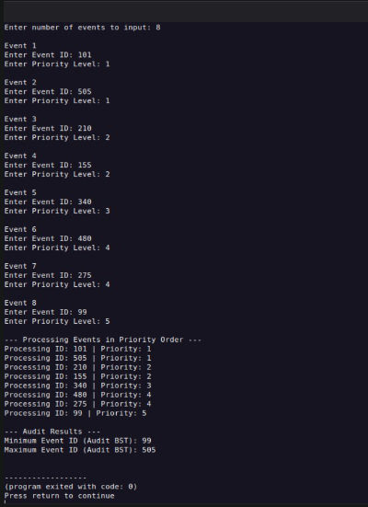

2. Analysis & Evaluation
Time Complexity:
- Priority Queue Insertion (Array-based): O(n). Because the array must remain
sorted by priority, every new insertion requires shifting existing elements
to make room.
- Priority Queue Deletion: O(1). Since the array is pre-sorted, the highest
priority event is always at the starting index.
- BST Operations (Min/Max): Average O(log n). However, if IDs are entered in
a sorted manner, the tree becomes skewed, and complexity degrades to O(n).
Impact of Poor Design:
- Reliability: Using an array for a Priority Queue is acceptable for small
datasets (like 8 events), but in a city with thousands of sensors, the O(n)
shifting would cause the system to lag.
- Safety: If the system takes too long to process a high-priority "Ambulance
Routing" event because it is busy shifting "Routine Maintenance" data in an
array, it could lead to critical delays in emergency response times.

Reference: I) https://www.w3schools.com/dsa/dsa_data_binarysearchtrees.php
II) https://en.wikipedia.org/wiki/Priority_queue

